Subject: IT 221 - IT ELECTIVE 3 – WEB SYSTEM & TECHNOLOGIES
Prof: Leo P. Paliuanan
leopaliuanan@csu.edu.ph

UNIT 1 – Overview

Topics
  - www,
  - web pages,
  - web sites,
  - Web browsers
  - web applications,
  - web services and;
  - web servers
At the end of this course, you will be able to identify the following:
- What is www,
- Web pages vs web sites
- Web browsers
- What are web applications
- Web services and web servers
Course Content
- www

The World Wide Web (abbreviated as WWW or W3, commonly known as the Web) is a system of interlinked hypertext documents that are accessed via the Internet. With a web browser, one can view web pages that may contain text, images, videos, and other multimedia and navigate between them via hyperlinks.

The Origin of the Web

Originally promoted the World Wide Web as a virtual library document control system for sharing information resources among researchers’ Online documents could be accessed via a unique document address, a Universal Resource Locator (URL)These documents could be cross-referenced via hypertext links

The World Wide Web abbreviated as WWW and commonly known as the web. The WWW was initiated by CERN (European library for Nuclear Research) in 1989.

History
It is a project created, by Timothy World Wide Web Consortium (W3C), which was developed for further development in the Berner’s Lee in 1989, for researchers to work together effectively at CERN. is an organization, named web. This organization is directed by Tim Berner’s Lee, aka the father of the web.

System Architecture
From the user’s point of view, the web consists of a vast, worldwide connection of documents or web pages. Each page may contain links to other pages anywhere in the world. The pages can be retrieved and viewed by using browsers of which internet explorer, Netscape Navigator, Google, Chrome, etc are the popular ones. The browser fetches the page requested interprets the text and formatting commands on it, and displays the page, properly formatted, on the screen.

Working of WWW

The World Wide Web is based on several different technologies: Web browsers, Hypertext Markup Language (HTML) and Hypertext Transfer Protocol (HTTP).

A Web browser is used to access webpages. Web browsers can be defined as programs which display text, data, pictures, animation and video on the Internet. Hyperlinked resources on the World Wide Web can be accessed using software interface provided by Web browsers. Initially Web browsers were used only for surfing the Web but now they have become more universal. Web browsers can be used for several tasks including conducting searches, mailing, transferring files, and much more. Some of the commonly used browsers are Internet Explorer, Opera Mini, Google Chrome.

Features of WWW
- HyperText Information System
- Cross-Platform
- Distributed
- Open Standards and Open Source
- Uses Web Browsers to provide a single interface for many services
- Dynamic, Interactive and Evolving.
- “Web 2.0”

Components of Web: There are 3 components of web:
- Uniform Resource Locator (URL): serves as system for resources on web.
- HyperText Transfer Protocol (HTTP): specifies communication of browser and server.
- Hyper Text Markup Language (HTML): defines structure, organisation and content of webpage.

Purposes of World Wide Web

The World Wide Web, or Internet, was created to provide an information highway to any person that is looking for specific pieces of information. It was created to help bring many people together and to provide information as well as entertainment to the people who choose to use it.

- Electronic mail. At least 85% of the inhabitants of cyberspace send and receive e-mail. Some 20 million e-mail messages cross the Internet every week.

- Research.

- Downloading files.

- Discussion groups. These include public groups, such as those on Facebook and the private mailings like google

- Interactive games. Who hasn’t tried to hunt down at least one game?

- Education and self-improvement. On-line courses and workshops have found yet another outlet.

- Friendship and dating. You may be surprised at the number of electronic “personals” that you can find on the World Wide Web.

- Electronic newspapers and magazines. This category includes late-breaking news, weather, and sports. We’re likely to see this category leap to the top five in the next several years.

- Job-hunting. Classified ads are in abundance, but most are for technical positions.

- Shopping. It’s difficult to believe that this category even ranks. It appears that “cybermalls” are more for curious than serious shoppers.

- web pages
Web Pages

A web page (or webpage) is a web document that is suitable for the World Wide Web and the web browser. A web browser displays a web page on a monitor or mobile device.

The web page is what displays, but the term also refers to a computer file, usually written in HTML or comparable markup language, whose main distinction is to provide hypertext that will navigate to other web pages via links.

Web browsers coordinate web resources centered around the written web page, such as style sheets, scripts and images, to present the web page.

A web page or webpage is a document, commonly written in HTML, that is viewed in an Internet browser. A web page can be accessed by entering a URL address into a browser's address bar. A web page may contain text, graphics, and hyperlinks to other web pages and files.

A web page is often used to provide information to viewers, including pictures or videos to help illustrate important topics. A web page may also be used as a method to sell products or services to viewers. Multiple web pages make up a website, like our Computer Hope website.

When you click a link provided by a search engine, you are accessing a web page. The Internet consists of millions of web pages, with more being added every day.
- web sites
A website, also written as web site, or simply site, is a set of related web pages typically served from a single web domain.

A website is hosted on at least one web server, accessible via a network such as the Internet or a private local area network through an Internet address known as a Uniform resource locator (URL). All publicly accessible websites collectively constitute the World Wide Web.

A website is a collection of publicly accessible, interlinked Web pages that share a single domain name. Websites can be created and maintained by an individual, group, business or organization to serve a variety of purposes.

the difference between a website and web page?
A website refers to a central location containing more than one web page. For example, Computer Hope is considered a website, which includes thousands of different web pages, including this web page you are reading now.

Web Page vs. Website

A Web site is more than just a group of web pages that are connected to each other through hypertext linksAt the lowest level, there are content-related concernsMaintaining thematic consistency of content is important in giving a site some degree of identityThere are also a esthetic concernsA Web site should also have a common look and feel across all of its pagesA common style across the site: page layout, graphic design, and typographical elements should reflect that styleThere are also architectural concernsAs a site grows in size and becomes more complexIt becomes critically important to organize its content properlyNot only the layout of individual page but the interconnection between them.

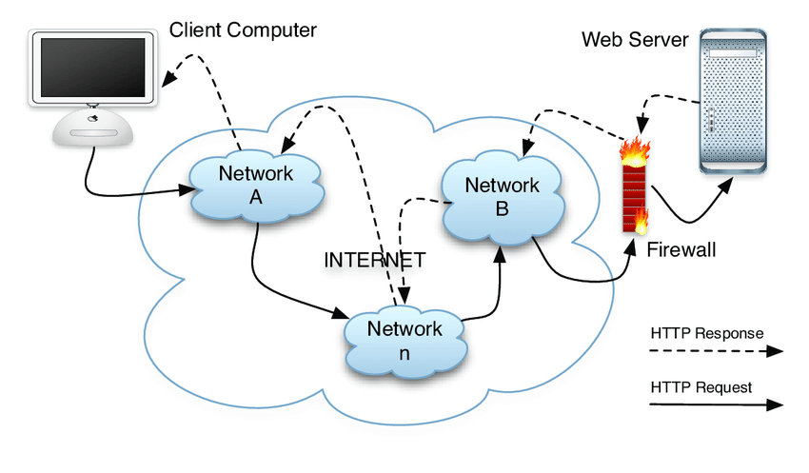
- Web browsers
A browser is an application program that provides a way to look at and interact with all the information on the World Wide Web. This includes Web pages, videos and images. The word "browser" originated prior to the Web as a generic term for user interfaces that let you browse (navigate through and read) text files online. Many people will use web browsers today for access to the internet and is seen almost as a necessity in how many navigate their daily life.

A Web browser is a client program that uses HTTP (Hypertext Transfer Protocol) to make requests of Web servers throughout the Internet on behalf of the browser user. Most browsers support e-mail and the File Transfer Protocol (FTP), but a Web browser is not required for those Internet protocols and more specialized client programs are more popular.

Web Browsers
The purpose of a web browser (Chrome, Edge, Firefox, Safari) is to read HTML documents and display them correctly.
A browser does not display the HTML tags, but uses them to determine how to display the document:
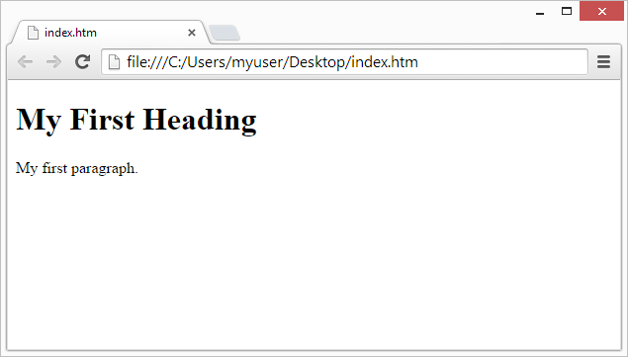

Web browser history

The first Web browser, called World Wide Web, was created in 1990. That browser's name was changed to Nexus to avoid confusion with the developing information space known as the World Wide Web. The first Web browser with a graphical user interface was Mosaic, which appeared in 1993. Many of the user interface features in Mosaic went into Netscape Navigator. Microsoft followed with its Internet Explorer (IE).

Common Web browser features
Most Web browsers share standard features such as:
- A home button- which, when selected, will bring a user to a pre-defined homepage.
- A Web address bar, which allows users to input a Web address and visit a website.
- Back and forward buttons- which will take the user to the previous or the next page they were on.
- Refresh- a button which can be used to reload a Web page.
- Stop- a button which makes a Web cease communication with a Web server, stopping a page from loading.
- Tabs- which allow users to open multiple websites in a single window.
- Bookmarks- which allow a user to select specific, predefined-by-the-user websites.

- web applications
A web application or web app is any application software that runs in a web browser and is created in a browser-supported programming language (such as the combination of JavaScript, HTML and CSS) and relies on a web browser to render the application.It is more than a websiteIt is a client server applicationA Web site simply delivers content from static filesA Web application presentsdynamically content based on request parameters, tracked user behaviors, and security considerations.

How a web application works
Web applications are usually coded in browser-supported language such as JavaScript and HTML as these languages rely on the browser to render the program executable. Some of the applications are dynamic, requiring server-side processing. Others are completely static with no processing required at the server.
The web application requires a web server to manage requests from the client, an application server to perform the tasks requested, and, sometimes, a database to store the information. Application server technology ranges from ASP.NET, ASP and ColdFusion, to PHP and JSP.
Here's what a typical web application flow looks like:
- User triggers a request to the web server over the Internet, either through a web browser or the application’s user interface
- Web server forwards this request to the appropriate web application server
- Web application server performs the requested task – such as querying the database or processing the data – then generates the results of the requested data
- Web application server sends results to the web server with the requested information or processed data
- Web server responds back to the client with the requested information that then appears on the user’s display

Example of a web application
Web applications include:
- online forms,
- shopping carts,
- word processors,
- spreadsheets,
- video and photo editing,
- file conversion,
- file scanning, and email programs such as Gmail,
- Yahoo.
- Popular applications include Google Apps and Microsoft 365.

Benefits of a web application
- Web applications run on multiple platforms regardless of OS or device as long as the browser is compatible
- All users access the same version, eliminating any compatibility issues
- They are not installed on the hard drive, thus eliminating space limitations
- They reduce software piracy in subscription-based web applications (i.e. SaaS)
- They reduce costs for both the business and end user as there is less support and maintenance required by the business and lower requirements for the end user’s computer
- web services
“What is a web service?” But, essentially, web services include any software, application, or cloud technology that provides standardized web protocols (HTTP or HTTPS) to interoperate, communicate, and exchange data messaging – usually XML (Extensible Markup Language) – throughout the internet.
In other words, web services are XML-centered data exchange systems that use the internet for A2A (application-to-application) communication and interfacing. These processes involve programs, messages, documents, and/or objects.
A key feature of web services is that applications can be written in various languages and are still able to communicate by exchanging data with one another via a web service between clients and servers. A client summons a web service by sending a request via XML, and the service then responses with an XML response. Web services are also often associated with SOA (Service-Oriented Architecture).
To break that down, a web service comprises these essential functions:
- Available over the internet or intranet networks
- Standardized XML messaging system
- Independent of a single operating system or programming language
- Self-describing via standard XML language
- Discoverable through a simple location method
A web service supports communication among numerous apps with HTML, XML, WSDL, SOAP, and other open standards. XML tags the data, SOAP transfers the message, and WSDL describes the service’s accessibility.
Here’s an instance of how it works: A web service sits between two sets of java, .net, or PHP apps providing a way for these applications to communicate over a network. On one side, for example, a java app interacts with the java, .net, and PHP apps on the other end by way of the web service communicating an independent language.
Web services offer different benefits across business operations. The technology helps IT pros and web architects streamline connectivity by minimizing development time. And with this simplified infrastructure, company executives begin to see higher ROI (return on investment). In a B2B operation where both parties understand how the process works, web services provide efficient technology distribution throughout an entire network.

What are the Different Types of Web Services?
There are a few central types of web services: XML-RPC, UDDI, SOAP, and REST:
XML-RPC (Remote Procedure Call) is the most basic XML protocol to exchange data between a wide variety of devices on a network. It uses HTTP to quickly and easily transfer data and communication other information from client to server.

UDDI (Universal Description, Discovery, and Integration) is an XML-based standard for detailing, publishing, and discovering web services. It’s basically an internet registry for businesses around the world. The goal is to streamline digital transactions and e-commerce among company systems.
SOAP, which will be described in detail later in the blog, is an XML-based Web service protocol to exchange data and documents over HTTP or SMTP (Simple Mail Transfer Protocol). It allows independent processes operating on disparate systems to communicate using XML.
REST, which will also be described in great detail later in the blog, provides communication and connectivity between devices and the internet for API-based tasks. Most RESTful services use HTTP as the supporting protocol.
Here are some well-known web services that use markup languages:
- Web template
- JSON-RPC
- JSON-WSP
- Web Services Description Language (WSDL)
- Web Services Conversation Language (WSCL)
- Web Services Flow Language (WSFL)
- Web Services Metadata Exchange (WS-MetadataExchange)
- XML Interface for Network Services (XINS)
- web servers
The term web server, also written as Web server, can refer to either the hardware (the computer) or the software (the computer application) that helps to deliver web content that can be accessed through the Internet.

The most common use of web servers is to host websites, but there are other uses such as gaming, data storage, running enterprise applications, handling, FTP, or other web uses.
Web servers
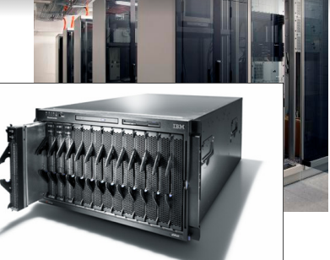
Web server: software that listens for web page requests
- Apache
- Microsoft Internet
- Information Server (IIS)

Application Server
Software framework that provides an environment where applications can run
- Apache
- Glassfish
- WebSphere
- WebLogic

